Access and Station Mode

## Introduction

There are several ways in which the ESP8266 can be configured to operate in. These modes determine what state the NodeMCU will be in during project implementation.

The NodeMCU ESP8266 module can be configured to operate in three different modes. These are:

* Station modes
* Access point mode
* Automatically connect to an already existing router.

## Objectives

* To program the NodeMCU to operate in two different modes namely the Access point mode and the Station mode.

## Literature Review

In Access point mode configuration, the ESP8266 sets up its own Wi-Fi network and acts as a hub (router) for one or more stations. It does not have to interface with or to a wireless network.

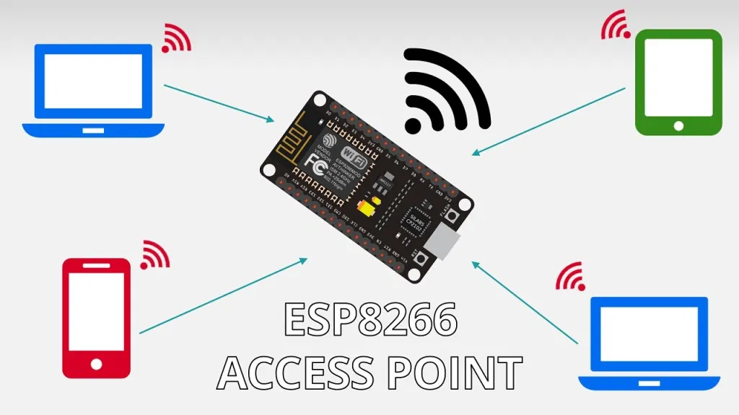

In Station mode the NodeMCU connects to an already set up wireless network. In this configuration, we connect the ESP8266 to a wireless router.

We can access the ESP8266 through the local network. This means that the router acts as an access point and the ESP8266 is set as a station. So, you need to be connected to your router (local network) to control the ESP8266.

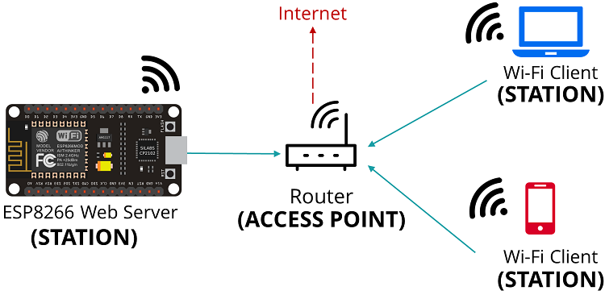

## Methodology

Schematics featured in Fritzing file.

## Equipment - Bill of Materials

* NodeMCU ESP8266 module
* Button
* LED
* Jumper wires
* Breadboard
* 220ohm resistor

## Flowchart

POWER THE NODEMCU WHILE PRESS THE SWITCHING BUTTON

NODEMCU IS IN ACCESS POINT MODE

ESP8266 CONNECTS TO THE WEB USING AN IP ADDRESS

SIGN IN TO AN EXISTING ROUTER SSID

NODEMCU IS IN STATION MODE

## Conclusion

From the research and review shown above, we demonstrated how to set the ESP8266 as a soft access point. This allows you to connect to the ESP8266 web server directly via Wi-Fi without the need to connect to a router.